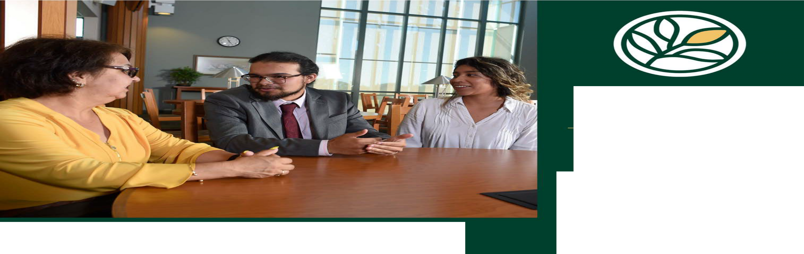

**TRANSLATION & INTERPRETING**

Translation and Interpreting is among the fastest growing careers in the nation!

# Mandatory Information Session via Zoom:

Wednesday, April 24, 2024, from 6:30-8:30 pm

[RSVP Link:](https://forms.office.com/r/XyyVw6XjSn)

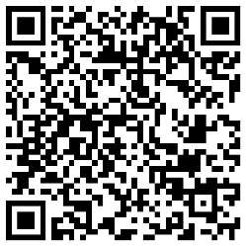

# Translation & Interpreting (T&I) Entrance Tests Via Zoom

For more information, contact:

## Claudia Schalesky

Program Coordinator and T & I Instructor

[claudia.schalesky@evc.edu](mailto:claudia.schalesky@evc.edu) 408-274-7900 ext. 6233

## Alejandro J. Ramos Torres

Academic Counselor 408-274-7900, ext 6218

Our Spanish Translation & Interpreting Program proudly fulfills the Public Service

Career Pathway.

Get started today!

Read more at:

[EVC T&I Link](https://www.evc.edu/programs-academics/academic-resources/divisionsdepartments/translation-and-interpreting-program)

Classes start 8/2024

**Oral Test: Pick 1 date**

1. Thursday, April 25, 6:30-8:30 pm
2. Friday, April 26, 10:00 am – 1:00 pm
3. Wednesday, May 1, 6:30-8:30 pm
4. Thursday, May 2, 6:30-8:30 pm

**Written Test:**

Tuesday, May 7, 7:00-8:00 pm

3095 Yerba Buena Road San Jose, CA 95135

408-274-7900 I **evc.edu**