Anxiety Toolbox

Student Workbook


Adapted from the University of California, Santa Cruz Counseling and Psychological Services Anxiety Toolbox Series

Table of Contents

Welcome  Frequently Asked Questions  Session 1 Worksheets  Stress Curve  Anxiety-Avoidance Roller Coaster  Threat System (Fight or Flight)  Common Anxiety Symptoms  CBT Model Worksheet (example)  CBT Model Worksheet (blank)  Sleep Hygiene  Homework Assignment  CBT Model Worksheets (blank)  Session 2 Worksheets  CBT Model Worksheet (example)  Unhelpful Thinking Styles  Identifying Triggers Worksheet  Homework Assignments  Homework: Identifying Triggers  CBT Model Worksheet (blank)  Session 3 Worksheets  Alternative Response Worksheet (example)  If You’re Having Trouble …  Alternative Response Worksheet (blank)  Pleasant Activities  My Plan for Managing Anxiety  Appendix  Stress Versus Anxiety  Understanding Anxiety Disorders  Grounding Exercises  Breathing Exercises  Feelings Wheel  Online Resources  Apps  References | Page 3  Page 4  Page 5  Page 6  Page 6  Page 7  Page 8  Page 9  Page 10  Page 11  Page 12  Page 13  Page 16  Page 17  Page 18  Page 20  Page 21  Page 22  Page 24  Page 27 Page 28  Page 29  Page 31  Page 34  Page 35  Page 37  Page 38  Page 39  Page 40  Page 42  Page 43  Page 44  Page 44  Page 45

Welcome!

Welcome to Anxiety Toolbox, a fast-paced, three-session seminar intended to help increase your understanding and knowledge about anxiety. The goal is to provide you with some skills to recognize and manage symptoms you may be experiencing. We hope you find it helpful.

The goal of this seminar is to provide you with life-long tools you can use while facing anxiety-triggering situations. Remember, this intervention is not intended to “get rid of” your anxiety. While occasionally unpleasant, some anxiety can be a helpful and motivating emotion. Our hope is that these three sessions provide you with a jumping board from which to integrate skills into your daily life in the service of reducing anxiety.

By the end of this course, you will have received a lot of information and at times it may feel overwhelming. Remember that like any skill (e.g., learning to ride a bike), the skills you will learn in Anxiety Toolbox take time and practice to master. At times, you may encounter obstacles and/or find it difficult to integrate these skills into your daily life. That’s okay, it’s how change works, and as with all change, it’s important to practice as much as you can, even after encountering setbacks.

Think of your practice of these skills as a form of “mental health hygiene.” At the outset, it may seem tedious, and you may question why you need to practice these skills so often. Think of it like dental hygiene—you brush your teeth multiple times a day to prevent the buildup of plaque and ultimately to prevent cavities. Like brushing your teeth, daily practice prevents a buildup of anxiety and stress over time. The more you practice and use these skills as part of your daily routine, the less tedious they may seem because they simply become a regular part of daily life.

Should you wish to focus more in depth on any of your anxiety related concerns, you may debrief with a therapist following completion of Anxiety Toolbox to discuss options.

If at any time you feel that you need additional support, please let your Anxiety Toolbox leader know or contact EVC Health and Wellness at 408-270-6480. You may also find additional resources online at https://www.evc.edu/wellness

Frequently Asked Questions (FAQ)

What is Anxiety Toolbox?
Anxiety Toolbox is a fast-paced three-session seminar specifically designed to help people who struggle with a variety of anxiety-related concerns (e.g., panic attacks, Generalized Anxiety, test anxiety). The goal of this seminar is to provide education on anxiety and to teach coping skills for managing anxiety symptoms.

Why does Anxiety Toolbox use a 3-session model?
Teaching Anxiety Toolbox over the course of 3 sessions allows you sufficient time to learn the concepts with time to practice between sessions. Keeping it to three 60-minute sessions allows you to find time in your busy schedule to learn these skills.

What if I need more than 3 weeks to learn the model?
You are not alone. The skills taught in Anxiety Toolbox are difficult and take time to build. For this reason, we offer a follow up anxiety group intended to provide further support for practicing these skills.

What if I don’t feel comfortable in groups?
Many people feel a little anxious about participating in a group. Anxiety Toolbox is structured and curriculum-driven, like an academic class. You are not required to speak to the entire group if you do not feel comfortable doing so. The facilitators respect each participant’s right to share only what they are comfortable sharing and never require you to share sensitive or potentially embarrassing information about yourself.

What if I have an urgent need to see a counselor during Anxiety Toolbox?
Simply let the facilitator or Counseling Services’ front desk staff know and they will facilitate you getting the help you need.

Why do I have to do homework?
The focus of this workshop is on building skills to cope with anxiety; in order to achieve that goal, regular practice is essential. The more you practice, the more you may find you get out of this workshop. The assignments are for you and only you, in the service of your own personal growth. You will not be required to provide your responses at any time during this workshop; however, it’s important to bring your responses as you may be asked to look back on or elaborate on a prior assignment during the workshop.

What if I didn’t do my homework?
We encourage you to come to group regardless of whether you were able to complete the homework assignment. If you forget your workbook, we can provide you a new one. We can also assist you in working on examples when the homework is reviewed.

SESSION 1:
ANXIETY 101

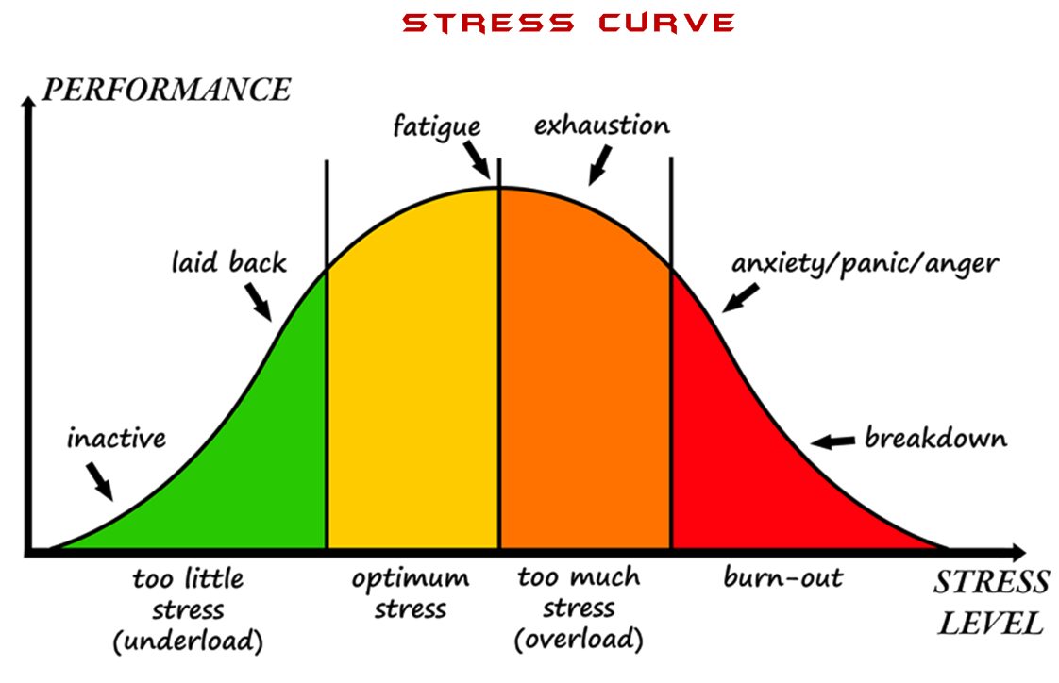
https://www.pinclipart.com/pindetail/iTJboRb_pictures-of-stress-stress-levels-clipart/
Anxiety - Avoidance Roller Coaster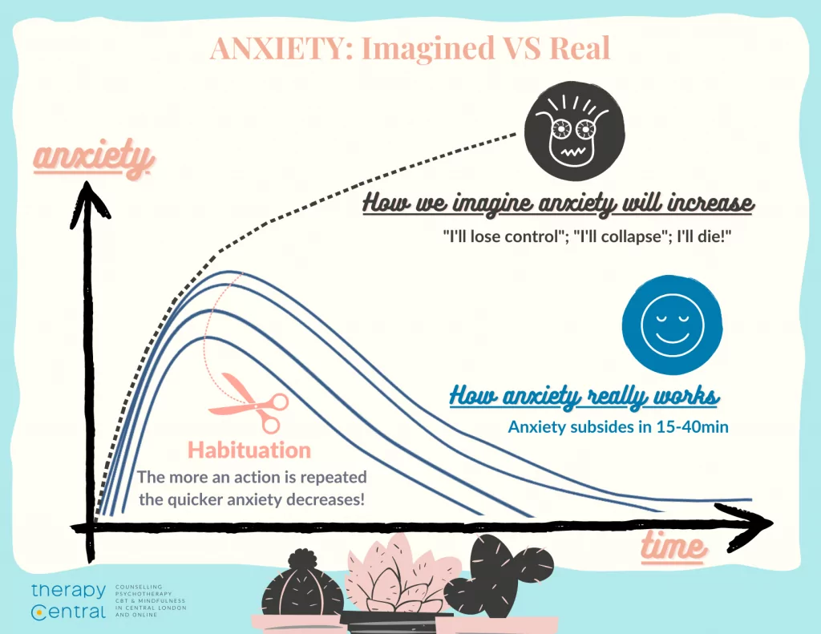
https://therapy-central.com/2021/02/19/cbt-for-anxiety/

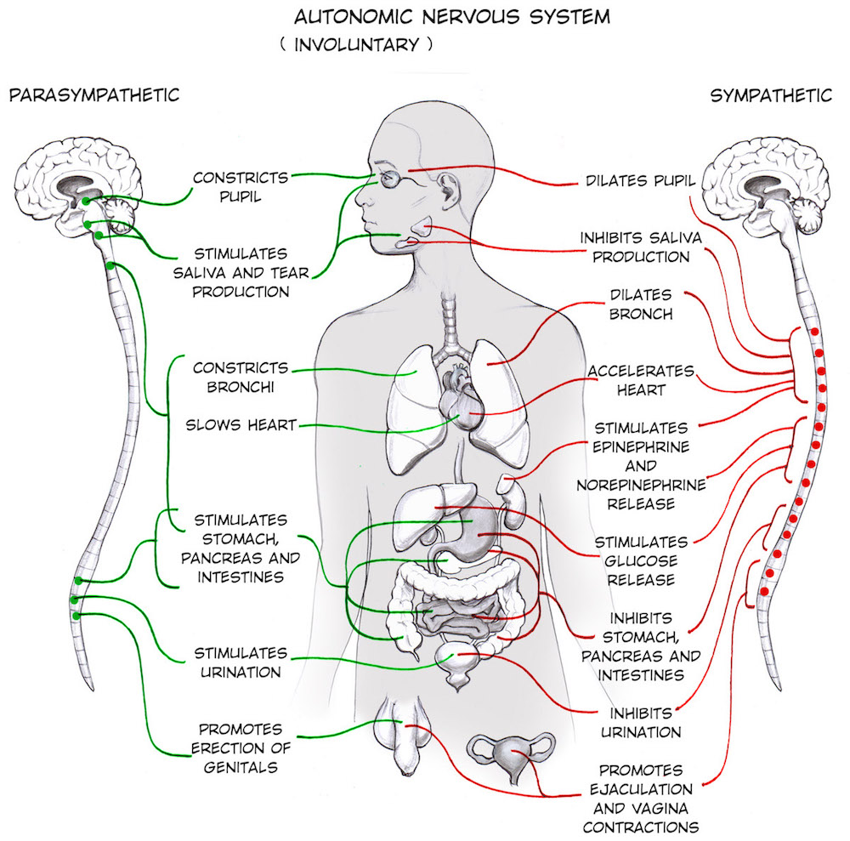

https://backyardbrains.com/experiments/Sympathetic_Nervous_System

Common Anxiety Symptoms
American Psychiatric Association. (2022). The diagnostic and statistical manual DSM-5TR.

Behavioral Symptoms
- Restlessness, feeling keyed up, feeling on edge
- Being easily fatigued
- Muscle tension
- Sleep Disturbance
  - Difficulty falling or staying asleep
  - Restless, unsatisfying sleep

Cognitive Symptoms
- Difficulty concentrating or mind going blank

Emotional Symptoms
- Excessive anxiety/worry
- Fear/anxiety in social situations

Panic Attacks (can occur)
- Palpitations, pounding heart, accelerated heart rate
- Sweating
- Trembling/shaking
- Sensations of shortness of breath or smothering
- Feeling of choking
- Chest pain/discomfort
- Nausea/abdominal distress
- Feeling dizzy/unsteady/lightheaded/faint
- Chills/heat sensations
- Paresthesia (numbness/tingling)
- Derealization (feelings of unreality) or Depersonalization (detachment from oneself)
- Fear of losing control or “going crazy”
- Fear of dying

Cognitive Behavioral Model
Situation (When? Where? What? With whom? What did you feel anxious about?)
A student invited me to a party in my residence hall, but I didn’t know her very well and felt anxious about going.

Physical (When anxious, what physical sensations did you experience? What did you notice in your body?)

Heart racing, tight chest, shallow breathing, hot flashes

Cognitive (What went through your mind when you felt anxious? What did that say or mean about you or the situation?)

I won’t know anyone at the party and will feel awkward. No one will like me because I’m so socially awkward. I won’t have fun. But if I say no, this person won’t like me and I wouldn’t make friends.

Behavioral (What was your first instinct and/or automatic response? What did you do and/or avoid doing at the time?)

My first instinct was to say no. I avoided saying no but telling her that I would think about it. I never got back to her. I didn’t go to the party.

Emotional (What emotions came up for you when you felt anxious?)

Scared, ashamed,
Lonely, agitated, nervous

CBT Model Worksheet

Situation (When? Where? What? With whom? What did you feel anxious about?)

Physical (When anxious, what physical sensations did you experience? What did you notice in your body?)

Behavioral (What was your first instinct and/or automatic response? What did you do and/or avoid doing at the time?)

Emotional (What emotions came up for you when you felt anxious?)

Cognitive (What went through your mind when you felt anxious? What did that say or mean about you or the situation?)

Sleep Hygiene

What is Sleep Hygiene? This is a term that basically means having good sleep habits. Following are some tips, based upon current research on Sleep Hygiene, that are aimed at increasing sleep quality. Research suggests that doing these things can improve your sleep quality.

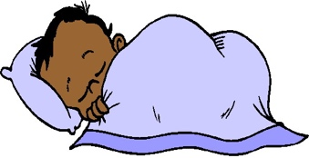
- Get regular. Set a sleep and wake time that stays consistent, even on weekends and days off!
- Get up & try again. Try to wait to go to bed until you are tired. If unable to fall asleep after 30 minutes, get up and do a calming task (such as reading) until you feel sleepy again, before you return to bed to try to sleep again.

- Avoid caffeine & nicotine. Stop all caffeine (coffee, tea, soda, chocolate) or nicotine (cigarettes) intake at least 4-6 hours before bedtime. Research has shown that stimulants interfere with ability to fall asleep.
- Avoid alcohol. Stop alcohol consumption at least 4-6 hours before bedtime, as it can impact quality of sleep.
- Bed is for sleeping. We want our bodies to associate bed with sleep, so avoid using the bed for anything by sleep or sex.
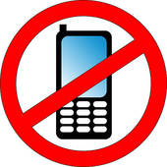
- Electronics Curfew. The artificial lights in back-lit electronics impact our body’s neurological sleep processes. Stop electronic usage 60 minutes prior to bedtime to enhance ability to fall asleep.
- The right space. Create a quiet and comforting sleeping environment. You can use an eye mask and/or earplugs to create darkness and quiet, if needed.
- No naps. Naps for longer than 20 minutes or after 3pm in the day have the potential to reset your circadian rhythm. For that reason, avoid naps, if possible.

- Sleep rituals. We want to train our bodies to prepare for sleep. Creating a ritual (e.g., bedtime stretches) can help.
- No clock-watching. Watching the clock and counting the hours of sleep one will get will just increase anxiety and negatively impact sleep
- Keep daytime routine the same. Sleeping in after poor sleep will impact sleep the next day. Try to keep the daytime routine as planned and you will be more tired at bedtime that day.

Adapted from http://www.cci.health.wa.gov.au

Session 1: Homework Assignment

Homework 1: Complete at least 1 Simple CBT Model Worksheet for review next week (multiple blank copies provided starting on page 15)

Homework 2: Practice Deep Breathing

Homework 3: Implement 1 Sleep Hygiene Tip

CBT Model Worksheet

Situation (When? Where? What? With whom? What did you feel anxious about?)

Emotional (What emotions came up for you when you felt anxious?)

Physical (When anxious, what physical sensations did you experience? What did you notice in your body?)

Cognitive (What went through your mind when you felt anxious? What did that say or mean about you or the situation?)

Behavioral (What was your first instinct and/or automatic response? What did you do and/or avoid doing at the time?)

CBT Model Worksheet

Situation (When? Where? What? With whom? What did you feel anxious about?)

Physical (When anxious, what physical sensations did you experience? What did you notice in your body?)

Behavioral (What was your first instinct and/or automatic response? What did you do and/or avoid doing at the time?)

Emotional (What emotions came up for you when you felt anxious?)

Cognitive (What went through your mind when you felt anxious? What did that say or mean about you or the situation?)

Situation (When? Where? What? With whom? What did you feel anxious about?)

CBT Model Worksheet

Physical (When anxious, what physical sensations did you experience? What did you notice in your body?)

Behavioral (What was your first instinct and/or automatic response? What did you do and/or avoid doing at the time?)

Cognitive (What went through your mind when you felt anxious? What did that say or mean about you or the situation?)

Emotional (What emotions came up for you when you felt anxious?)

SESSION 2:
AUTOMATIC THOUGHTS
AND UNHELPFUL
COGNITIONS

CBT Model Worksheet

Situation (When? Where? What? With whom? What did you feel anxious about?)
A student invited me to a party in my residence hall, but I didn’t know her very well and felt anxious about going.
Physical (When anxious, what physical sensations did you experience? What did you notice in your body?)

Heart racing, tight chest, shallow breathing, hot

Cognitive (What went through your mind when you felt anxious? What did that say or mean about you or the situation?)

I won’t know anyone at the party and will feel awkward. No one will like me because I’m so socially awkward. I won’t have fun. But if I say no, this person won’t like me and I wouldn’t make friends.

Behavioral (What was your first instinct and/or automatic response? What did you do and/or avoid doing at the time?)

My first instinct was to say no. I avoided saying no but telling her that I would think about it. I never got back to her. I didn’t go to the party.

Emotional (What emotions came up for you when you felt anxious?)

Scared, ashamed,
Lonely, agitated, nervous

Unhelpful Patterns of Thinking

Cognitive Distortions)
Images from: https://clipart-library.com/


All-or-Nothing / Black and White Thinking:
- Seeing things in extremes, not seeing the grey areas
-- Ex: “If I’m not perfect I have failed”

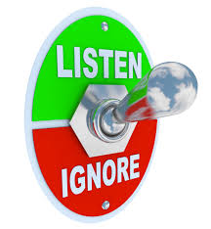
Mental Filter / Selective Evidence:
- Only noticing things that confirm what we already believe
- Can foster optimism and pessimism about the world


Jumping to Conclusions / Mind Reading
- Inaccurate belief that we know what others are thinking/feeling
-- Ex: “My friend is frowning, that means they hate me”

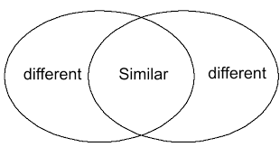
Overgeneralization
- Drawing broad conclusions from a single event
-- Ex: “I got a bad grade on an exam, so I stupid and failure”


Disqualifying the positive:
- Discounting the good things that have happened for some reason
-- Ex: “My boss said I did a good job, but they were just being nice”


Magnification and Minimization:
- Blowing things out of proportion or inappropriately minimizing their importance


Rigid Thinking:
- Using critical words like ‘should’ or ‘must’, resulting in feelings of guilt and shame, resentment and anger

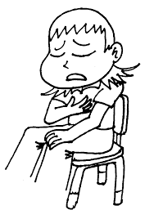
Emotional Reasoning:
- Taking feelings as facts
-- “I feel it, so it must be true”


Labeling and Mislabeling:
- Assigning value to ourselves and others based on one instance/experience


Personalization:
- Blaming oneself or taking things personally, without logical reason

Identifying Triggers Worksheet

While at times it may be difficult to identify a trigger, understanding your triggers for anxiety is an important step in helping you know when to implement and/or emphasize practice of the coping strategies you will learn in Anxiety Toolbox. Triggers can be external events (e.g., a test) or internal stimuli (e.g., a physical sensation or emotion) that led to your experience of anxiety (i.e., the emotional, physical, cognitive, and behavioral symptoms previously discussed during this workshop). Remember that sometimes the symptoms themselves can be a trigger that starts the cycle of anxiety.

The following are some typical categories in which triggers might appear with examples:

Responses to Internal Stimuli:
- Emotions: e.g., feeling down, fear or worry
- Mental Images: e.g., replaying interpersonal interactions or performance experience
- Physical State: e.g., racing heartbeat, lightheadedness, tightness in chest
- Thoughts: e.g., “I might fail this test”, “That person must not like me”, “If someone talks to me in class, I won’t be able to handle it.”

Responses to External Stimuli:
- Presence of Others: e.g., attending a social event, meeting with a professor, spending time with roommates, family interactions
- Physical Setting: e.g., a classroom, open areas on campus, inside a car
- Social Pressure: e.g., feeling pressured to make friends, feeling pressured to perform well in school (in comparison to your peers)
- Activities: e.g., a sports event, a party, going home for the weekend

List some triggers you experience related to your anxiety:
1._______________________________________________________________________________________________
2._______________________________________________________________________________________________3._______________________________________________________________________________________________4._______________________________________________________________________________________________5._______________________________________________________________________________________________

Session 2 Homework Assignments

Homework 1: Complete Identifying Triggers Worksheet on pages 22 and 23.

Homework 2: Complete at least 1 Simple CBT Model Worksheet for review next week (multiple blank copies provided starting on page 24).

Homework: Identifying Triggers

Pay attention to any triggers for anxiety that you may experience over the next week. Write them down in the following categories. You may have triggers in all of the categories, or you may notice triggers in only one or two categories. (Use the “other” category for triggers you feel don’t fit in the options listed.)

Emotions:
1.________________________________________________________________________________________
2.________________________________________________________________________________________
3.________________________________________________________________________________________
Mental Images:
1.________________________________________________________________________________________
2.________________________________________________________________________________________
3.________________________________________________________________________________________
Physical States:
1.________________________________________________________________________________________
2.________________________________________________________________________________________
3.________________________________________________________________________________________
Thoughts:
1.________________________________________________________________________________________
2.________________________________________________________________________________________
3.________________________________________________________________________________________

Presence of Others:
1.________________________________________________________________________________________
2.________________________________________________________________________________________
3.________________________________________________________________________________________
Physical Setting:
1.________________________________________________________________________________________
2.________________________________________________________________________________________
3.________________________________________________________________________________________
Social Pressure:
1.________________________________________________________________________________________
2.________________________________________________________________________________________
3.________________________________________________________________________________________
Activities:
1.________________________________________________________________________________________
2.________________________________________________________________________________________
3.________________________________________________________________________________________
Other:
1.________________________________________________________________________________________
2.________________________________________________________________________________________
3.________________________________________________________________________________________

CBT Worksheet

Situation (When? Where? What? With whom? What did you feel anxious about?)

Physical (When anxious, what physical sensations did you experience? What did you notice in your body?)

Behavioral (What was your first instinct and/or automatic response? What did you do and/or avoid doing at the time?)

Emotional (What emotions came up for you when you felt anxious?)

Cognitive (What went through your mind when you felt anxious? What did that say or mean about you or the situation?)

CBT Model Worksheet

Situation (When? Where? What? With whom? What did you feel anxious about?)

Physical (When anxious, what physical sensations did you experience? What did you notice in your body?)

Behavioral (What was your first instinct and/or automatic response? What did you do and/or avoid doing at the time?)

Emotional (What emotions came up for you when you felt anxious?)

Cognitive (What went through your mind when you felt anxious? What did that say or mean about you or the situation?)

CBT Model Worksheet

Situation (When? Where? What? With whom? What did you feel anxious about?)

Physical (When anxious, what physical sensations did you experience? What did you notice in your body?)

Behavioral (What was your first instinct and/or automatic response? What did you do and/or avoid doing at the time?)

Emotional (What emotions came up for you when you felt anxious?)

Cognitive (What went through your mind when you felt anxious? What did that say or mean about you or the situation?)

SESSION 3:
ALTERNATIVE RESPONSES, GROUNDING, AND SELF-CARE; PUTTING IT ALL
TOGETHER

Alternative Response Model
Situation: (When? Where? What? With whom? What did you feel anxious about?)
A student invited me to a party in my residence hall, but I didn’t know her very well and felt anxious about going.

Alternative Thoughts and Images: (Are these thoughts helpful? Are the anxious thoughts 100% true/accurate, 100% of the time? What are other ways of looking at this? What is the bigger picture?)  I may not be as socially awkward as I think.  If she invited me, she probably wants me there.  I might still have an okay time even if I am anxious | Alternative Behaviors: (What could you do that would be more helpful for you, others, &/or the situation? What are coping strategies that might be helpful?)  Coping Strategies I Can Use:  - Deep breathing  - Distract myself  - Seek support from a friend/ family member  - Do a pleasurable activity  - Use alternative response worksheet | Alternative Feelings: (What are feelings that are more helpful? What if you acted and thought differently about the situation? How might these changes help you feel differently?)  Excited  Wanted  Liked  Hopeful
Original Outcome: (What was the original outcome?) I stayed in my room and watched Netflix.
Desired Outcome: (Using these new alternatives, what would you like the outcome to be in the future?) I want to go to the party so that I can make friends. If I feel too uncomfortable, I can always leave.
If you're having trouble, ask yourself these questions:
Whenever we recognize an anxiety-related thought, feeling or behavior, it can be very helpful to ask ourselves the following questions:

Alternative THOUGHTS:
- What are other ways of looking at this situation?
- Am I looking at the whole picture?
- What might be a more helpful way of picturing this situation?
- What unhelpful thinking styles might I be using here (see below)?
- What is the evidence that my thoughts are true? Is there an alternative way of thinking about this situation that is truer?
- What is the probability that my thoughts will happen? What are some other things that could happen that are equally, if not more, probable?
- Have I had any experiences in the past that suggests that this thought might not be COMPLETELY true ALL the time?
- Can I really predict the future? Is it helpful to try? What is more helpful?
- Am I exaggerating how bad the result might be? What is more realistic?
- Can I read people’s minds? What else might they be thinking (that’s not so negative)?
- If a friend or loved one were in this situation and had this thought, what would I tell them?

Common Cognitive Distortions (Unhelpful Thinking Styles)
All or Nothing Thinking: thinking in absolute, black and white categories | Over-Generalizing: seeing a pattern based upon a single event or being overly broad in conclusions we draw
Mental Filter: only paying attention to certain types of evidence (e.g., dwelling on the negatives) | Disqualifying the Positive: discounting the good things that have happened
Jumping to Conclusions:  Mind Reading: imagining we know what others are thinking  Fortune Telling: predicting the future | Magnification (Catastrophizing) and Minimization: blowing things out of proportion or inappropriately shrinking something to make it seem less important
Emotional Reasoning: assuming because we feel a certain way, what we think must be true | Should/Must Thinking: Using words like “should”, “must”, “ought to” or “have to”
Labeling: assigning labels to ourselves or others | Personalization: blaming yourself for something you weren’t entirely responsible for OR blaming others and overlooking ways you may have contributed to the outcome
Alternative BEHAVIORS:
- What could I do in the moment that would be more helpful?
- What’s the best thing to do (for me, for others, or for the situation)?
- If my feared situation happens, how will I cope? What coping skills can I use to handle my feared situation? What have I done in the past that was successful?
- Am I needing to work on acceptance, letting go of control, being okay with less than perfect, or having faith in the future and myself?
- Breathe: Focus your attention on your breathing. Imagine you have a balloon in your belly, inflating on the in-breath, deflating on the out-breath.

Alternative FEELINGS:
- What might it feel like if I acted/thought differently?
- When I’m not feeling this way, do I think about this situation differently?
- Are there any strengths or positives in me or the situation that I might be ignoring?
- What else might this anxiety be related to? Is it really about feeling _______?
- Tell yourself: “This feeling will pass. It’s a normal body reaction.”

Alternative Response Worksheet
Situation (When? Where? What? With whom? What did you feel anxious about?)

Alternative Thoughts and Images: (Are these thoughts helpful? Are the anxious thoughts 100% true/accurate, 100% of the time? What are other ways of looking at this? What is the bigger picture?) | Alternative Behaviors: (What could you do that would be more helpful for you, others, &/or the situation? What are coping strategies that might be helpful?)  Coping Strategies I Can Use:  - Deep breathing  - Distract myself  - Seek support from a friend/ family member  - Do a pleasurable activity  - Use alternative response worksheet | Alternative Feelings: (What are feelings that are more helpful? What if you acted and thought differently about the situation? How might these changes help you feel differently?)

Original Outcome: (What was the original outcome?)

Desired Outcome: (Using these new alternatives, what would you like the outcome to be in the future?)

Alternative Response Worksheet
Situation: (When? Where? What? With whom? What did you feel anxious about?)

Alternative Thoughts and Images: (Are these thoughts helpful? Are the anxious thoughts 100% true/accurate, 100% of the time? What are other ways of looking at this? What is the bigger picture?) | Alternative Behaviors: (What could you do that would be more helpful for you, others, &/or the situation? What are coping strategies that might be helpful?)  Coping Strategies I Can Use:  - Deep breathing  - Distract myself  - Seek support from a friend/ family member  - Do a pleasurable activity  - Use alternative response worksheet | Alternative Feelings: (What are feelings that are more helpful? What if you acted and thought differently about the situation? How might these changes help you feel differently?)

Original Outcome: (What was the original outcome?)

Desired Outcome: (Using these new alternatives, what would you like the outcome to be in the future?)

Alternative Response Worksheet
Situation: (When? Where? What? With whom? What did you feel anxious about?)

Alternative Thoughts and Images: (Are these thoughts helpful? Are the anxious thoughts 100% true/accurate, 100% of the time? What are other ways of looking at this? What is the bigger picture?) | Alternative Behaviors: (What could you do that would be more helpful for you, others, &/or the situation? What are coping strategies that might be helpful?)  Coping Strategies I Can Use:  - Deep breathing  - Distract myself  - Seek support from a friend/ family member  - Do a pleasurable activity  - Use alternative response worksheet | Alternative Feelings: (What are feelings that are more helpful? What if you acted and thought differently about the situation? How might these changes help you feel differently?)

Original Outcome: (What was the original outcome?)

Desired Outcome: (Using these new alternatives, what would you like the outcome to be in the future?)

Pleasant Activities
Acting | Amusing people | Attending a concert | Beachcombing | Being alone | Being with animals | Being at the beach
Being complimented | Being coached | Being counseled | Being in the country | Being at a family get-together | Being in a fraternity/  sorority | Being with friends
Being with happy people | Being in the mountains | Being with my roommate | Being with someone I love | Being told I am loved | Being with my parents | Birdwatching
Boating/ canoeing | Budgeting my time | Buying things for myself | Buying something for someone I care about | Camping | Caring for plants | Canning/ Making preserves
Cheering for something | Collecting things | Combing/ brushing my hair | Completing a difficult task | Complimenting or praising someone | Cooking | Counseling someone
Dancing | Dating someone I like | Designing/ Drafting | Discussing my favorite hobby | Doing artwork | Doing experiments | Doing favors for people I like
Doing housework | Dreaming at night | Driving long distances | Eating good meals | Exploring/ Hiking | Expressing love to someone | Feeling the presence of a Higher Power
Fishing | Fixing machines | Gardening/ Doing yardwork | Gathering natural objects | Giving gifts | Giving a party for someone | Getting up early
Getting massages | Giving massages | Going to an amusement park/ zoo | Going to a barber/ beautician | Going to a concert | Going to lectures | Going to a luncheon/ potluck
Going to a health club/ sauna/spa | Going to the movies | Going to a museum | Going on nature walks/ field trips | Going to a play | Going to a restaurant | Going to a reunion
Going to a spiritual/ peaceful place | Going to a sports event | Having coffee/tea with friends | Having daydreams | Having friends over to visit | Having a lively talk | Having lunch with friends
Having an original idea | Having spare time | Hearing jokes | Helping someone | Hiking | Horseback riding | Improving my health
Kicking sand/ pebbles/leaves | Kissing | Knitting/ crocheting | Laughing | Learning something new | Listening to the ratio | Listening to music
Looking at the stars/ moon | Making charitable donations | Making food to give away | Making a new friend | Meditating/ Doing yoga | Planning or organizing something | Playing sports
Playing cards | Playing music | Playing with a pet | Playing in nature | Playing a board game/ chess | Photography | Repairing things
Reading | Reminiscing | Riding in an airplane | Running/ jogging | Saying prayers | Seeing beautiful scenery | Seeing old friends
Sewing | Shaving | Singing | Sleeping late | Smelling a flower or plant | Seeing good things happen to people | Solving a puzzle/ crossword
Speaking a foreign language | Staying up late | Smiling at people | Taking a bath | Using my strengths | Watching TV | Writing in a journal

Putting it all Together:

My Plan for Managing Anxiety

- My primary anxiety symptoms include: (pg. 8)
  - Emotional:
  - Physical:
  - Cognitive:
  - Behavioral:

- Some of my unhelpful ways of thinking are: (e.g., all or nothing thinking, catastrophizing, etc.) (pg. 18 & 19)

- My situational and cognitive triggers are: (e.g., unfamiliar situations, negative thoughts, etc.) (pg. 20)

- The most helpful grounding techniques (pg. 40-41):

- The most helpful relaxation exercise:

- The best time and place to practice relaxation exercises:
- When I feel overwhelmed, it is helpful for me to: (pg. 29-30, 34, & 42)
- Positive changes I can make to help my sleep include: (e.g., no TV 30 minutes before bed, wake up at the same time daily, turn phone off, etc.)

- MY GOALS: Name 2 goals you would like to achieve over the next few months, related to anxiety and self-care. Think: specific, achievable, and measurable.
  - Name 2 goals you would like to achieve related to ANXIETY (e.g., Thinking about the strategies you find most helpful, what would you like to try, how often, when, etc.?)
    - ______________________________________________________________________
    - ______________________________________________________________________
  - Name 2 goals you would like to achieve related to SELF-CARE: (What will your self-care look like over the next few months? These could be goals related to nutrition, exercise, sleep, schoolwork, leisure activities, etc.)
    - _______________________________________________________________________
    - ________________________________________________________________________
- Reminder about plan and goals:
___________________________________________________________________________________
___________________________________________________________________________________
___________________________________________________________________________________

APPENDIX

Stress Versus Anxiety

Everyday Anxiety (Stress) | Anxiety Disorder
In response to a known environmental factor | In response to an unknown source or in response to the experience of stress
Symptoms go away when the stressor goes away | Symptoms remain despite no identifiable stressor
Worry about living away from home for the first time, passing a class, a romantic breakup, or other important life events | Constant and unsubstantiated worry that causes significant distress and interferes with your daily life
Embarrassment or self-consciousness in an uncomfortable or awkward social situation; feeling nervous about meeting new people | Avoidance of social situations due to fear of being judged, embarrassed, or humiliated
Feeling nervous or sweating before a big test, class presentation, stage performance, or other significant event | Panic attacks that seem out of the blue and preoccupation with the fear of having another one
Realistic fear of a dangerous object, place, or situation (e.g. fear of poisonous snakes) | Irrational fear or avoidance of an object, place, or situation that poses little or no threat of danger (e.g. fear of elevators)
Making sure that you are healthy and living in a safe environment | Performing uncontrollable repetitive actions, such as excessive cleaning, checking, touching or arranging

Adapted from: http://www.adaa.org/understanding-anxiety
Understanding Anxiety Disorders

While anxiety is a normal and adaptive experience for everyone, anxiety disorders are characterized by significant distress or impairment in social, academic/occupational, or other important areas of functioning (e.g., your general ability to function in life).

Some of the most common anxiety disorders include:

Generalized Anxiety Disorder: Chronic and unrealistic worry that feels difficult to control about everyday things (i.e., things that do not worry most people)

Social Anxiety Disorder: Chronic worry solely related to social situations

Panic Disorder: Characterized by episodes of “panic” that include things like adrenaline surge, fear of losing control, chest pain, racing heart, shortness of breath, dizziness

Phobias: Specific fears that are excessive in nature and often lead to avoiding that which is feared (e.g., public speaking, heights, tunnels, etc.)

Obsessive-Compulsive Disorder: Excessive rumination (thinking) with repetitive behaviors to reduce anxiety

Grounding Exercises

When people become overwhelmed with distressing thoughts or feelings, including intense anxiety, activities that keep your mind and body connected (called “grounding”) can be helpful in regaining a sense of stability and mental focus. The following are several grounding exercises to choose from to help firmly anchor you in the present moment and provide you with space to choose where to focus your energy. You may need to try multiple different exercises to find one or two that work best for you.

- Remind yourself of who you are now. State your name, age and where you are right now.

- Take ten slow deep breaths. Focus your attention on each breath on the way in and on the way out. Say the number of the breath to yourself as you exhale.

- Splash water on your face or place a cool wet cloth on your face.

- Pay purposeful attention as you hold a cold (non-alcoholic) beverage in your hands. Feel the coldness, and the wetness on the outside. Note the taste as you drink. You can also do this exercise with a warm beverage.

- Find a “grounding object” to hold, look at, listen to, and/or smell. This could be a soft object such as a pillow or stuffed animal, a smooth stone you found on the beach, a picture of a beautiful scene or loved one, and/or any other object that represents safety or comfort.

- Listen to music. Pay close attention and listen for something new or different.

- If you wake up suddenly during the night and feel disoriented or distressed, remind yourself who you are and where you are. Look around the room and notice familiar objects and name them. Feel the bed you are lying on, the softness of the sheets or blankets, the warmth or coldness of the air, and notice any sounds you hear. Remind yourself that you are safe.

- Feel the clothes on your body, whether your arms and legs are covered or not, and the sensation of your clothes as you move in them.

- While sitting, feel the chair under you and the weight of your body and legs pressing down on it.

- If you are lying down, feel the contact between your head, your body and your legs, as they touch the surface you are lying on. Starting from your head, notice how each part feels, all the way down to your feet, on the soft or hard surface.

- Stop, look, and listen. Notice and name what you can see and hear nearby and in the distance.

- Look around you, notice what is front of you and to each side, name first large objects and then smaller ones.

- Get up, walk around, take your time to notice each step as you take one then another.

- If you can, step outside, notice the temperature, the sounds around you, the ground under your feet, the smell in the air, etc.

- “54321” Grounding Exercise:
  - Name 5 things you can see in the room with you.
  - Name 4 things you can feel (tactile, e.g. “chair on my back” or “feet on floor”)
  - Name 3 things you can hear right now
  - Name 2 things you can smell right now
  - Name 1 good thing about yourself
- Write and/or say grounding statements
  - This situation won’t last forever
  - This too shall pass.
  - I can ride this out and not let it get me down.
  - My anxiety/fear/sadness won’t kill me; it just doesn’t feel good right now.
  - These are just my feelings and eventually they’ll go away.

Adapted from: http://www.livingwell.org.au/well-being/grounding-exercises/
Breathing Exercises
Belly (or Diaphragmatic) Breathing
You can do this exercise in any position, but it is helpful to do this exercise while lying down when first learning belly breathing.
- Lie comfortably on your back, with a pillow under your head, your knees bent and your back flat. You can stretch your legs out if that's more comfortable.
- Place one hand on your belly and one hand on your upper chest.
- Inhale slowly and expand your belly as you breathe so that your lower hand moves with your belly. The hand on your chest should remain as still as possible.
- Slowly exhale, focusing on the movement of your belly and lower hand as it returns to its original position.
- Repeat steps 3 & 4 for several minutes, always focusing on the movement of the belly as you breathe. If your mind wanders, gently bring your attention back to your breathing.

Breath-Counting Exercise
This exercise focuses on the use of counting with the rhythm of the breath. Start with a short period of time and gradually increase the time. Set a timer so that you do not have to worry about when to stop.
- Find a comfortable position. Take several deep breaths and settle into yourself. You may either close your eyes or keep them open, depending on your own comfort. If you keep them open, fix them on an object or a spot on the floor about four feet in front of you. Your eyes may be either focused or unfocused.
- Take deep, comfortable breaths. Notice your inhalation. The pause between inhaling and exhaling, your exhalation, and the pause before starting again.
- As you inhale, count, “one...” As you exhale, count, “two...” Inhale, “three...” Exhale, “four...” Continue until you reach 10 then start over.
- If you lose count, simply begin with “one” on your next inhalation.
- If you notice your mind has wandered, gently notice this, and return your focus back to counting your breath.
- If you notice any body sensations catching your attention, focus on that sensation until it fades. Then return your attention back to counting your breaths.
Feelings Wheel

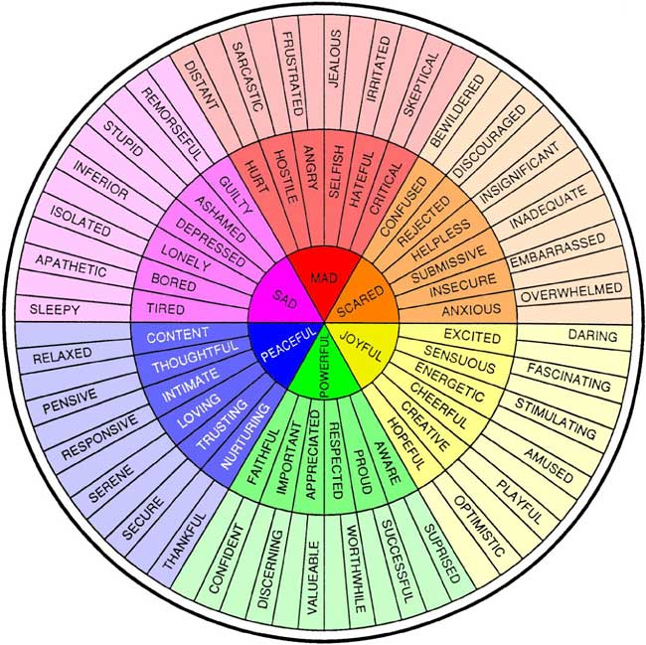

The Feelings Wheel was originally created by Dr. Gloria Wilcox. Wilcox, G. (1982). The feeling wheel. Transactional Analysis Journal, 12(4), 274-276. https://doi.org/10.1177/036215378201200411

Online Resources

Mayo Clinic Stress Reduction Website
http://www.mayoclinic.com/health/mindfulness-exercises/MY02124

Meditation Oasis www.meditationoasis.com

Mindful www.mindful.org

Mindfulness Research Guide http://www.mindfulexperience.org/

UCLA Mindful Awareness Research Center- Guided Medications
http://marc.ucla.edu/body.cfm?id=22

Apps for your Smartphone, Tablet, or Computer

ACT Coach
Breathe2relax
Breathing techniques by Hemalayaa
CBTi-Coach
Mindfulness Coach
Mindshift
T2 Mood Tracker
Take a break!

WellTrack

Books for Further Reading
The Anxiety and Phobia Workbook by Bourne (2011)
The Anxiety and Worry Workbook by Clark & Beck (2012)
Get Out of Your Mind and Into Your Life by Hayes & Smith (2005)
Self-Esteem by McKay and Fanning (2005)
The Mindful Way Workbook by Teasdale, Williams, Segal, & Kabat-Zinn (2014)
The Mindfulness Workbook: A Teach Yourself Guide by Langley (2013)
The Relaxation & Stress Reduction Workbook by Davis, Robbins, Eshelman & McKay (2008)

References
Images:
https://www.pinclipart.com/pindetail/iTJboRb_pictures-of-stress-stress-levels-clipart/
https://therapy-central.com/2021/02/19/cbt-for-anxiety/
https://backyardbrains.com/experiments/Sympathetic_Nervous_System
https://doi.org/10.1177/036215378201200411
https://clipart-library.com/

Sleep Hygiene Handout:
Adapted from http://www.cci.health.wa.gov.au

Stress Vs Anxiety Table:
Adapted from: http://www.adaa.org/understanding-anxiety

Grounding Exercise:
Adapted from: http://www.livingwell.org.au/well-being/grounding-exercises/

