Online Teaching Toolkit: EDIT Certificate

Introduction
Join our AI infused Online Teaching and Educational Technology Certificate program at Evergreen Valley College.
The EDIT curriculum combines proven online teaching principles with practical approaches to educational technology, including thoughtful integration of faculty-facing AI tools to support course development, assessment design, academic integrity, and student engagement.
Below is a snapshot of the EDIT Certificate pathway and course offerings
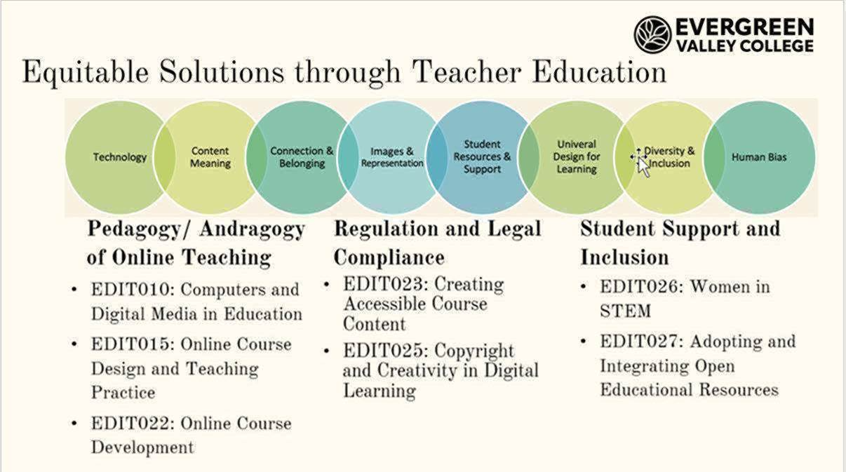
All the courses in the certificate (19 units) are online and Zero Text Cost (ZTC) ensuring accessible learning opportunities that feature:
- Faculty-focused AI literacy fundamentals
- Essential online teaching methodologies
- Strategic educational technology integration
- Inclusive digital learning strategies

Getting Started
- Current SJECCD students can enroll through Self-Service using the REG-ID#
- Faculty new to taking courses at EVC can register via the Apply Now link.
  - We recommend using your personal email not your school email when applying.
- SJECCD employees can utilize the class enrollment tuition fee waiver.
Enrollment note: If a class is full, please add yourself to the waitlist and contact the instructor. In some cases—especially in asynchronous online courses—sections may temporarily appear full due to inactive or invalid enrollments. These are reviewed and cleaned up during the first few days of class.

Help & Support
- For assistance with registration, please get in touch with your campus Admissions and Records (for EVC: tiffani.lam@evc.edu)
- For information on moving up the salary scale, please get in touch with PRC Chair Eric Narveson (eric.narveson@evc.edu): (PRC Handbook attached)
- For help with counseling in this Certificate of Achievement, please get in touch with Tina Iniguez (tina.iniguez@evc.edu)
- For login or account issues please contact ITSS at 408-270-6411

Tuition Waiver and Approval
For the tuition waiver and approval, please complete the Employee Fee Waiver form and send it to the indicated HR personnel as soon as possible.
- Full-Time faculty at either EVC or SJCC, send to Eileen Luna (Eileen.Luna@sjeccd.edu)
- Part-time faculty at EVC send to Stacy Alvarez (Stacy.Alvarez@evc.edu)
- Part-time faculty at SJCC send to Sandra Gonzalez (Sandra.Gonzalez@sjcc.edu)

If the approved fee waiver is not submitted, you will be responsible for paying the $140 enrollment fee.
Be sure to log in to Self-Service regularly to check for updates regarding your enrollment status.

